SOFTWARE REQUIREMENTS SPECIFICATION
For
Web-Based Patient Scheduling and Program Management System for Barangay Health Center

Prepared by:
Celestial ART
Angala, Regin
Rosal, Angel
Tabunyag, Jonalyn
Submitted in fulfillment requirements for Integrative Programming and Technologies 2 (IT305)
Table of Contents
Table of Contents ii
1. Introduction 1
1.1 Purpose 1
1.2 Intended Audience 1
1.3 Product Scope 1
1.4 Definitions, Acronyms, and Abbreviations 1
2. Overall Description 2
2.1 User Characteristics 2
2.2 Constraints 3
2.3 Assumptions and Dependencies 3
3. Requirements Specifications 4
3.1 Functional Requirements 4
3.2 Non-Functional Requirements 4
3.3 External Interface Requirements 6
3.4 System Models 6
3.5 Database Design 7
3.6 Implementation 7
3.7 Testing and Deployment 7

Introduction
In the present time, people can no longer imagine their lives without technology. The rapid growth of the technology sector has led to the development of numerous innovations that have transformed the way people work, communicate, and live. Among these, the computer stands out as one of the most significant tools, as it supports individuals in completing office tasks, conducting business transactions, and providing various forms of entertainment. Computers, along with modern technologies, have made manual processes faster, easier, and more efficient.
As society continues to progress, individuals and organizations increasingly rely on technology to enhance their daily activities. One particular sector that benefits greatly from technological advancements is healthcare. Health centers perform numerous daily tasks, from managing patient records to scheduling appointments, which are often time-consuming when done manually.
This project is design to address significant administrative and healthcare delivery challenges through a comprehensive digital solution. Barangay Health Center plays a vital role in delivering essential healthcare services to the community. However, the center faced inefficiencies caused by manual record-keeping processes and limited resources. These issues hindered effective healthcare delivery, prompting the need for modernization to optimize resource utilization and enhance access to healthcare services.
The main challenge tackled by this project was the reliance on manual systems for patient scheduling and program management. This outdated approach resulted in delays in healthcare delivery, mismanagement of resources, and challenges in implementing health programs. These inefficiencies directly affected the residents’ ability to access timely and effective care. Resolving these issues was crucial not only to improve service delivery but also to align with the government’s push for digitalization and modernization in healthcare.
This project focuses on the development of system design to improve the operations of health centers. One of the system’s key features is its ability to automate patient appointment scheduling. This eliminates long wait times and minimizes scheduling conflicts, allowing healthcare staff to focus more on providing quality care. The system centralizes patient medical histories, ensuring that healthcare providers have access to accurate and up-to-date information. This improves the quality of care and enables better decision-making. Centralized records also allow for seamless program coordination, which is vital for implementing health initiatives in Barangay. With its program management features, the system optimizes resource allocation and ensures the timely execution of healthcare initiatives. From vaccination drives to feeding programs, the system simplifies coordination and enhances outcomes. This aligns with the government’s digitalization initiatives aimed at improving public healthcare services.

Purpose

The Web-Based Patient Scheduling and Program Management System for Barangay Health Center is design to automate key processes at Barangay Health Center. It will streamline patient appointment scheduling, track medical histories, and facilitate program management. Additionally, the system will provide tools for generating automated reports and reminders, which enhanced administrative workflows and reduced manual workload. The design prioritized user-friendliness, security, and scalability to ensure that the system could adapt to future healthcare needs. The solution was tailored to the health center’s unique requirements, ensuring its practicality and long-term relevance.

Intended Audience
The intended audience are the patients/residents, Health Workers, and Barangay Health Personnel.
  - Product Scope
The Web-Based Patient Scheduling and Program Management System for Barangay Health Center is design to provide a comprehensive digital solution that modernizes the health center’s administrative and healthcare service delivery processes. This system aims to automate critical tasks, including patient appointment scheduling, medical record management, and healthcare program coordination, thereby enhancing the overall efficiency of health services.
Key Features
- Centralized Database: The system ensures accurate, secure, and easily accessible patient information. This centralized approach enables healthcare providers to make informed decisions and deliver quality care.
- Appointment Management: An integrated appointment management feature reduces waiting times, minimizes scheduling conflicts, and enhances efficiency in handling large volumes of patients. This feature is crucial for optimizing patient flow and improving service delivery.
- Program Management: The system includes tailored program management features for community health initiatives, such as vaccination drives, maternal care programs, feeding programs, and other government-mandated health activities. These features improve coordination, optimize resource allocation, and ensure timely execution of health programs.
- Automated Notifications and Reminders: To support both patients and healthcare workers, the system incorporates automated notifications and reminders via email. This functionality improves patient engagement and ensures better compliance with healthcare schedules.
- Reporting Tools: Built-in reporting tools allow staff to generate accurate and real-time reports for monitoring and evaluation. This aligns with the government’s digitalization and modernization goals, facilitating better decision-making and resource management.

  - Definitions, Acronyms, and Abbreviations
    - Definitions
- Web-Based System – A software application that runs on a web server and is accessed through a web browser, enabling users to interact with the system online without requiring installation on individual computers.
- Patient Scheduling – The process of organizing and managing appointments between patients and healthcare providers to ensure timely and efficient delivery of healthcare services.
- Program Management – The planning, coordination, and execution of healthcare-related activities or initiatives such as vaccination drives, feeding programs, and maternal care programs within the community.
- Automated Notifications and Reminders – System-generated alerts sent to patients or healthcare staff (via email) to remind them of upcoming appointments, health programs, or other relevant healthcare schedules.
- Healthcare Provider – Refers to doctors, nurses, midwives, and Barangay Health Workers (BHWs) who deliver medical and healthcare services to the community.
- Barangay Health Center – A community-level healthcare facility that provides primary medical and preventive services to residents within a barangay.

    - Acronyms and Abbreviations
- BHC – Barangay Health Center
- BHW – Barangay Health Worker
- DB – Database
- EHRS – Electronic Health Record System
- UI – User Interface
- UX – User Experience
- DOH – Department of Health

- Overall Description
2.1 User Characteristics
- Patients: Basic computer/mobile literacy; minimal training required.
- Doctors/Nurses: Familiar with medical record handling; may require short orientation on digital usage.
- Midwives: They act as community front-liners, providing health education on family planning and immunization, and referring high-risk cases to hospitals.
- System Admin: Develops and manages server security, backup and recovery plans.
- Barangay Health Personnel: The one who generate reports, create and manage residents’ login credentials
2.2 Constraints
The system development and implementation are subject to the following limitations:
- Technical Resources – Limited availability of hardware (computers, servers, and stable internet connectivity) in the Barangay Health Center may affect system performance.
- Budget – Financial constraints may limit the procurement of advanced technologies or additional system features beyond the essential requirements.
- User Accessibility – The design should be simple, mobile-friendly, and usable by individuals with basic digital skills.
- Connectivity – The system relies on internet access for web-based functionality. Poor or unstable internet connections in certain areas may hinder performance.
- Data Privacy and Compliance – The system must adhere to data privacy regulations (e.g., Data Privacy Act of 2012 in the Philippines), which may restrict certain data-handling procedures.

2.3 Assumptions and Dependencies
- Users (patients, doctors, nurses, midwives, and Barangay Health Workers) will have access to mobile devices or computers with internet connectivity to interact with the system.
- The Barangay Health Center will provide the necessary infrastructure (internet connection, computers, and power supply).
- Users will cooperate in adopting the system, including attending basic training sessions.
- Patients will have valid and accessible email addresses for receiving appointment reminders, updates, and follow-up notifications.
- Patient data provided during registration will be accurate and updated regularly by healthcare personnel.

3. Requirements Specifications
3.1 Functional Requirements.
- Login
  - Support secure login with credentials (username/email and password).
  - Provide role-based access (patients, healthcare staff, and admin).
  - Enable password recovery/reset via email.
- Authentication & Security
  - Encrypt passwords before storing them in the database.
  - Implement session management to prevent unauthorized access.
  - Automatic logout after a period of inactivity.
- Profile Management
  - Users (patients & staff) can view and update personal information.
  - Healthcare staff can update professional details (specialization, role).
  - Admin can update, suspend, or delete user accounts.
- Admin Dashboard
  - Manage all registered users (view, add, edit, delete).
  - Assign and modify roles (patient, doctor, nurse, midwife, BHW).
  - Generate reports on user activity (logins, failed attempts).
  - Oversee system logs for monitoring and auditing.
- System Feedback
  - Display confirmation/error messages during signup, login, and account updates.
  - Provide validation for incorrect input (e.g., empty fields, invalid email format).
3.2 Non-Functional Requirements.
- Performance
- System should process login requests within 3 seconds.
- Signup and admin actions (add/edit users) should not exceed 5 seconds.
- Security
- Data must comply with the Data Privacy Act of 2012.
- Use HTTPS for secure communication.
- Admin role protected with additional security (e.g., two-factor authentication).
- Usability
- The interface should be user-friendly and mobile-responsive.
- Minimal training required; intuitive design consistent with prototype.
- Scalability
- Support growing numbers of users and healthcare staff.
- Allow future integration with appointment and medical record systems.
- Availability & Reliability
- System uptime must be at least 95%.
- Provide recovery mechanisms in case of server or database failure.
3.3 External Interface Requirements.
- User Interfaces
- Web-based responsive UI (desktop and mobile).
- Signup, Login, and Admin Dashboard follow the design guidelines.
- Admin dashboard must include tables for user management and reporting tools.
- Hardware Interfaces
- Accessible via standard computers and mobile devices.
- Requires stable internet connection.
- Software Interfaces
- Database for storing user credentials and roles.
- Email API for verification, notifications, and password recovery.
- Compatible with modern web browsers (Chrome, Edge, Firefox, Safari).
- Communication Interfaces
- Secure communication using HTTPS.
- Email notifications for signup confirmation, password reset, and admin alerts.
3.4 System Model
Use Case Diagram
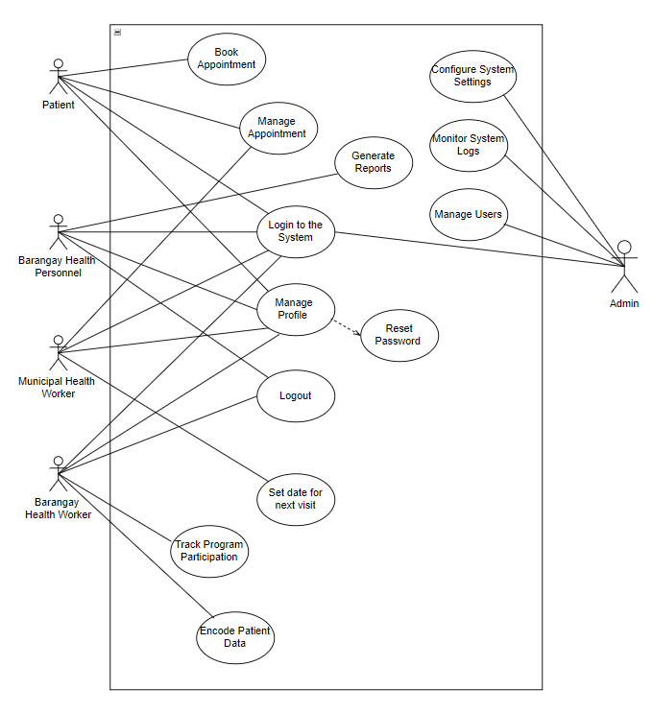

3.5 Database Design
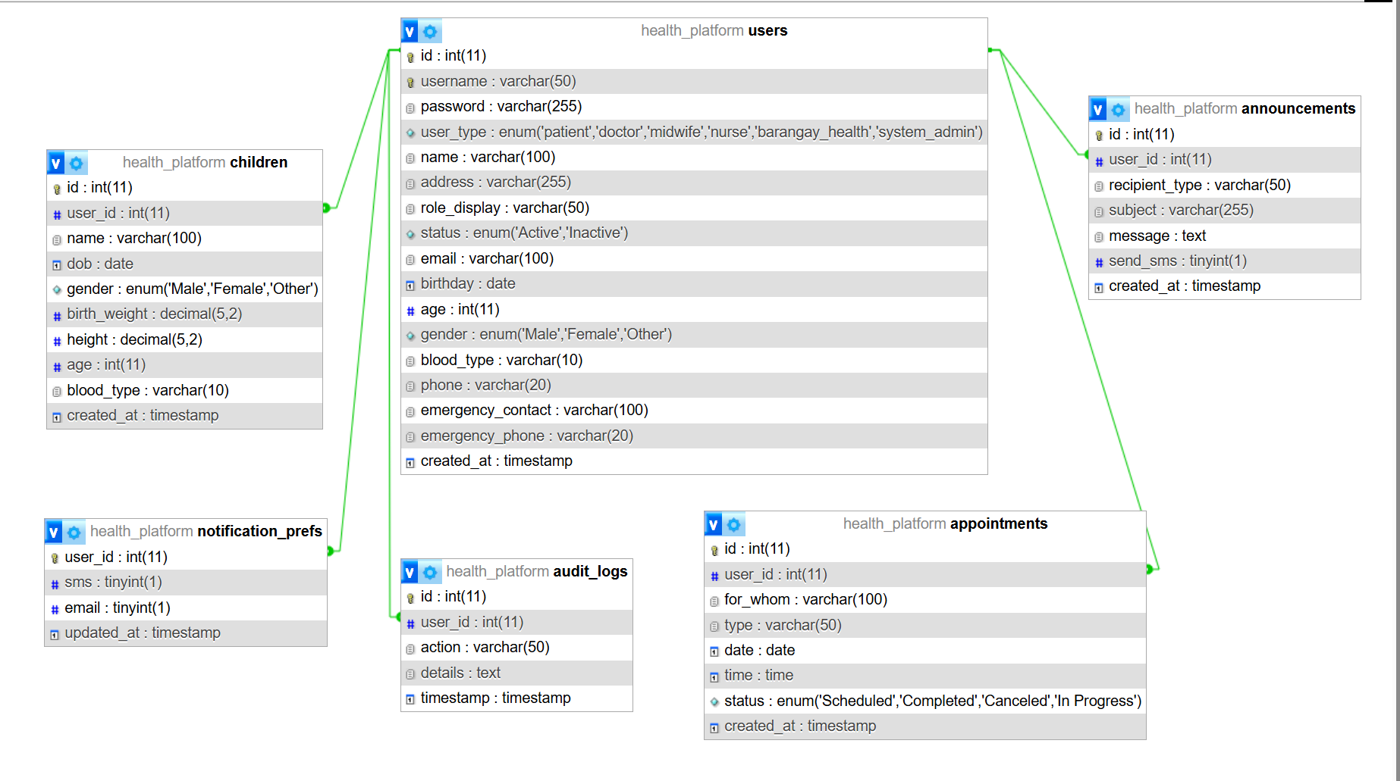

3.6 Implementation
The development of the Web-Based Patient Scheduling and Program Management System was carried out using a structured and modular approach to ensure maintainability, scalability, and ease of deployment. The system was implemented in a web-based environment to allow accessibility through standard web browsers on both desktop and mobile devices.
    - Development Environment
The system was developed using a Windows-based environment with Visual Studio Code as the primary integrated development environment (IDE). A local web server was configured using XAMPP, which provided Apache, MySQL, and PHP for development and testing. The system was tested locally before deployment to a live server environment.
- Operating System: Windows 10 / 11
- IDE: Visual Studio Code
- Local Server: XAMPP (Apache, MySQL, PHP)
- Web Browser for Testing: Google Chrome

    - Programming Languages
The project utilized a combination of front-end and back-end programming languages to ensure interactive and secure web functionality.
- HTML – For creating the structure and layout of web pages.
- CSS – For styling and responsive design across devices.
- JavaScript – For client-side interactivity and dynamic content.
- PHP – For server-side scripting, user authentication, and database interaction.
- (MySQL) – For database management and query execution.
    - Frameworks and Libraries
To enhance development efficiency and ensure a modern user interface, several frameworks and libraries were integrated into the project:
- jQuery – For simplifying JavaScript operations and DOM manipulation.
- PHPMyAdmin – For database management and testing.

    - Tools and Utilities
Additional tools were used throughout the development process for version control, collaboration, and system optimization.
- Git and GitHub – For version control and collaborative code management.
- Figma / Canva – For UI/UX prototyping and design planning.
- Postman – For testing API endpoints and ensuring reliable communication between the client and server.
- Google Fonts & Icons – For enhancing the visual appeal and consistency of the user interface.

    - Deployment
The system was initially deployed on a local XAMPP server for testing and debugging, and later configured for web hosting to enable online access by Barangay Health Center staff and patients. The deployment process included creating a secure database connection, enabling HTTPS for secure data transmission, and configuring user roles to ensure data privacy and access control.

